* SAS : homework 10：

學號：b07401048 醫學五 姓名：賴柏瑞

* 1. Effect-measure modification：
     1. Result：
        1. RR difference：- 0.0336
        2. RR ratio = 0.975
     2. Figure：

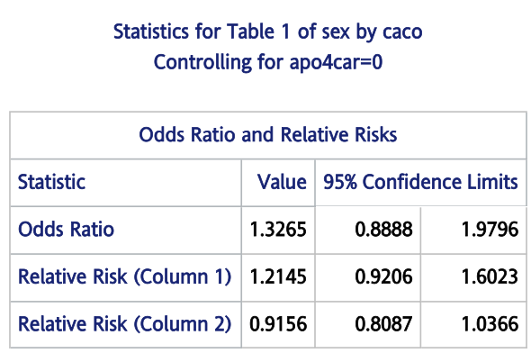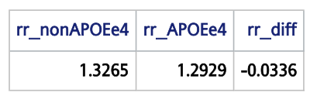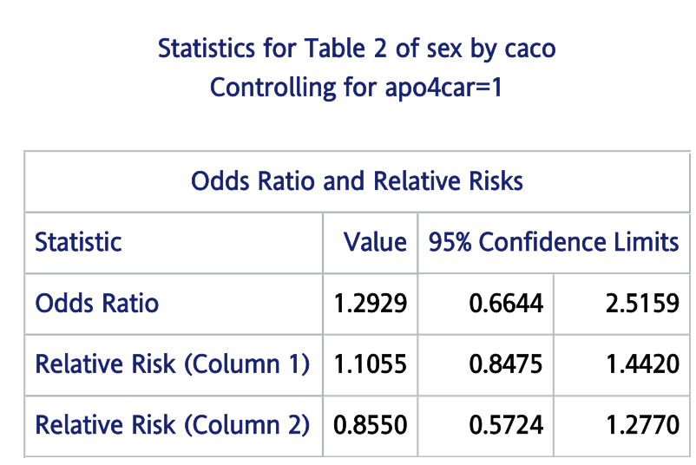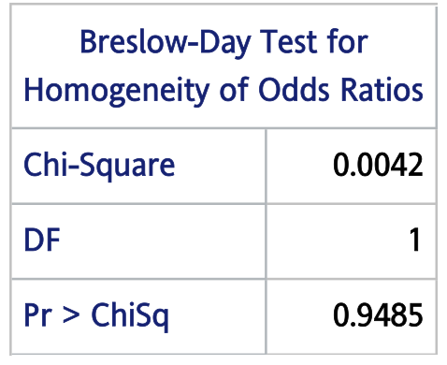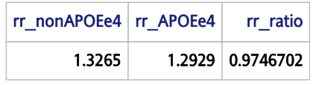

* + 1. Descriptions：

|  |  |  |  |  |  |
| --- | --- | --- | --- | --- | --- |
| Strata1：non-APOE e4 carrier | | | Strata 2：APOE e4 carrier | | |
|  | Case | Control |  | Case | Control |
| women | n00 = 84 | n10 = 161 | women | N00 = 64 | N10 = 36 |
| Men | n01 = 59 | n11 = 150 | Men | N01 = 33 | N11 = 24 |
| OR(n) | OR = | | OR(N) | OR = | |
| OR difference = OR(n) – OR(N) | | | | | |

* + - 1. 以APOE e4 status分層，觀察兩層中gender與AD的關係。定義women為exposure，men為non-exposure；發生AD為disease。
      2. 以上述公式計算兩層的OR。在non-carrier層的OR為1.3265（95% CI：0.8888 – 1.9796）；在carrier層的OR為1.2929（95% CI：0.6644 – 2.5159）
      3. 在抽樣與暴露與否相互獨立的前提下，可以OR推論RR。
      4. 計算兩層RR difference，將non-carrier層與carrier相減，得RR difference = -0.0336。以RR difference判斷兩層的RR相差不大（接近1），APOE e4 status應不造成effect-measure modification。
      5. 計算兩層RR ratio，將non-carrier層與carrier相除，得RR ratio = 0.9746702。兩層的RR相差不大，APOE e4 status應不造成effect-measure modification。
      6. 以Breslow-Day test檢定兩層之OR是否相等，檢定結果p-value為0.9485，無法拒絕虛無假說，兩層OR無顯著不同。表示APOE e4 status與gender較不可能有交互作用。

Code：

*/* homework 10 */*

dm "odsresult" clear;

dm "log" clear;

*/* import data of sasdataset*/*

libname data "\\Mac\Home\Desktop\";

*/* q1 : effect-measure modification , E1 ( women), DZ( AD) , stratified by APOE status*/*

title "q1";

**data** ad;

set data.ad_dataset_new;

**run**;

*/* Risk difference */*

**proc** **sort** data = ad;

by apo4car sex descending caco;

**run**;

**proc** **freq** data = ad order = data;

tables apo4car * sex * caco / or nocol nopercent cmh;

**run**;

**proc** **iml**;

rr_nonAPOEe4 = 1.3265;

rr_APOEe4 = 1.2929;

rr_diff = rr_APOEe4 - rr_nonAPOEe4;

print rr_nonAPOEe4 rr_APOEe4 rr_diff;

**run**;

*/* Rate difference */*

**proc** **iml**;

rr_nonAPOEe4 = 1.3265;

rr_APOEe4 = 1.2929;

rr_ratio = rr_APOEe4 / rr_nonAPOEe4;

print rr_nonAPOEe4 rr_APOEe4 rr_ratio;

**quit**;

* 1. Statistical interaction（adjusted for age , years of education）
     1. RR of gender and APOE e4 status and both
        1. Result：
           1. RR of APOE e4 status alone：3.495 ( 95% CI ：1.907 – 6.406 )
           2. RR of gender alone：1.326 ( 95% CI ：0.889 – 1.979 )
           3. RR of both APOE e4 status and gender： 4.518 ( 95% CI : 2.720 – 7.504 )
        2. 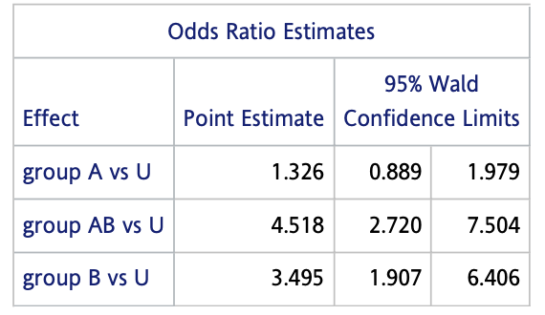Figure：
        3. Descriptions：

|  |  |  |
| --- | --- | --- |
|  | Men ( A’ ) | Women ( A ) |
| Non APOE e4 carrier ( B’ ) | RRU | RRA |
| APOE e4 carrier ( B ) | RRB | RRAB |

* + - * 1. RRA / RRU = 1.326，單純gender這個變項的RR為1.326。
        2. RRB / RRU = 3.495，單純APOE status的RR為3.495。
        3. 若不存在統計上的交互作用，則RRAB應為RRA  RR­B = 4.634。而RRAB = 4.518。兩者差異不大，叫不可能有統計上的交互作用
    1. Create a product interaction term (apo4car * sex) and run a logistic regression model：
       1. 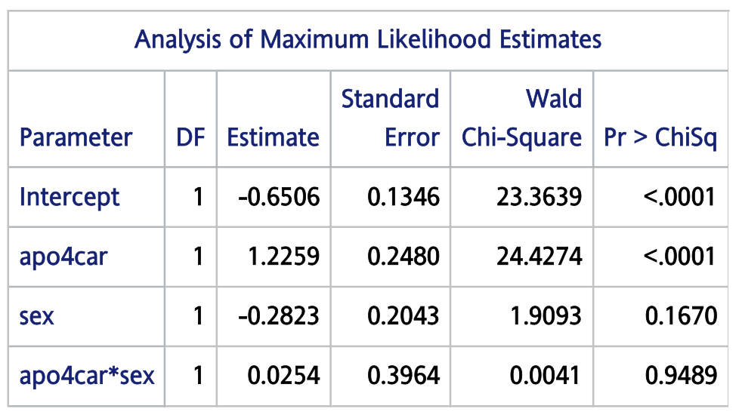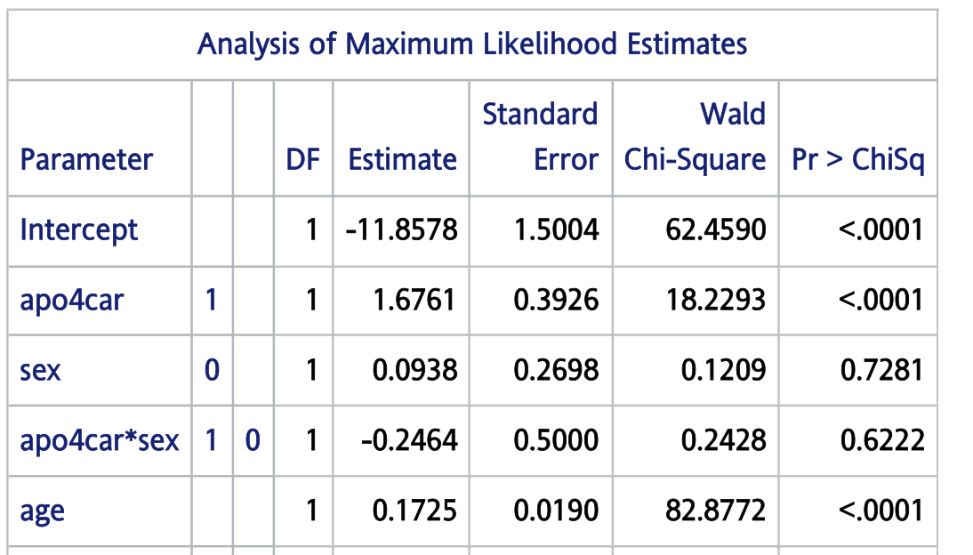Figures：
       2. Descriptions：
          1. 在加入age, education year這兩個變項前，apo4car * sex這個interaction term的p-value為0.9489，未達統計上顯著。
          2. 加入age, education year這兩個變項後，這個interaction term的p-value為0.6222，依然未達統計上的顯著。
          3. 表示APOE e4 status與sex沒有統計上的交互作用。
    2. Code：

*/* q2 : statistical interaction, Logistic regression */*

title "q2";

**data** q2;

set ad;

if apo4car = 1 and sex = 0 then group = "AB";

else if apo4car = 1 and sex = 1 then group = "B";

else if apo4car = 0 and sex = 0 then group = "A" ;

else if apo4car = 0 and sex = 1 then group = "U";

**run**;

**proc** **print** data = q2;

var apo4car sex group;

**run**;

**proc** **logistic** data = q2;

class group (ref = "U") / param = ref;

model caco (event = "1") = group;

**run**;

**proc** **iml**;

rr_a = 1.326;

rr_b = 3.495;

rr_ab = 4.518;

diff = rr_ab - (rr_a * rr_b);

percent_diff = abs(diff) / rr_ab;

print rr_a rr_b rr_ab diff percent_diff;

**quit**;

*/* unadjusted model */*

**proc** **logistic** data = q2;

class group (ref = "U") / param = ref;

model caco ( event = "1") = apo4car sex apo4car * sex;

**run**;

*/* adjusted model */*

**proc** **logistic** data = q2;

class apo4car (ref = "0") sex ( ref = "1") / param = ref;

model caco (event = "1") = apo4car sex apo4car * sex age eduyr;

**run**;

**proc** **logistic** data = q2;

class apo4car (ref = "0") sex ( ref = "1") / param = glm;

model caco (event = "1") = apo4car sex apo4car * sex;

lsmeans apo4car * sex / diff oddsratio;

**run**;

* 1. Biological interaction
     1. (
        1. Result：
        2. 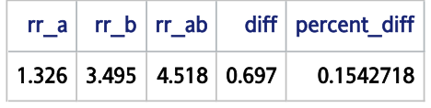Figure：
        3. Descriptions：

|  |  |  |
| --- | --- | --- |
|  | Men ( A’ ) | Women ( A ) |
| Non APOE e4 carrier ( B’ ) | RRU = 1 | RRA = 1.326 |
| APOE e4 carrier ( B ) | RRB = 3.495 | RRAB = 4.518 |

* + - * 1. 若biological interaction不存在，則
        2. 本題上式相減為0.697，佔RRAB的15.43%。代表有15.43% 的case是因為生物交互作用而產生。
    1. Statistical interaction 🡨🡪 biological interaction ：
       1. 若沒有statistical interaction，則RRAB應為4.634。
       2. 若沒有biological interaction，則RRAB應為3.785。
       3. 3.785 ( no biological interaction) < 4.515 ( observed ) < 4.634 ( no statistical interaction)，代表生物交互作用與統計交互作用的影響方向是反向的。
       4. 首先，是否具有生物交互作用，取決於其生理機轉及生物的本質。在本題中，APOE status與性別之間的交互作用不一定單純地符合相加效應，而可能有更複雜的機轉。是故本題計算生物交互用的方向及大小，不一定可真實反應其兩變項生理機轉的本質。
       5. 此外，統計的交互作用是否存在取決於模型的選擇，本題之模型為羅吉斯回歸，兩變項是否具有統計交互作用視其是否偏離相乘效應而定。受限於資料樣態和格式，羅吉斯回歸或為本題最適合的模型，然而此模型不一定可真實反應兩變項與AD的關係。
    2. Code：

*/* q3 : biological interaction */*

title "q3" ;

**proc** **iml**;

rr_a = 1.326;

rr_b = 3.495;

rr_ab = 4.518;

diff = (rr_ab - 1) - ((rr_a - 1) + (rr_b - 1));

percent_diff = abs(diff) / rr_ab;

print rr_a rr_b rr_ab diff percent_diff;

**quit**;